**Sentiment – iPhone versus Galaxy**

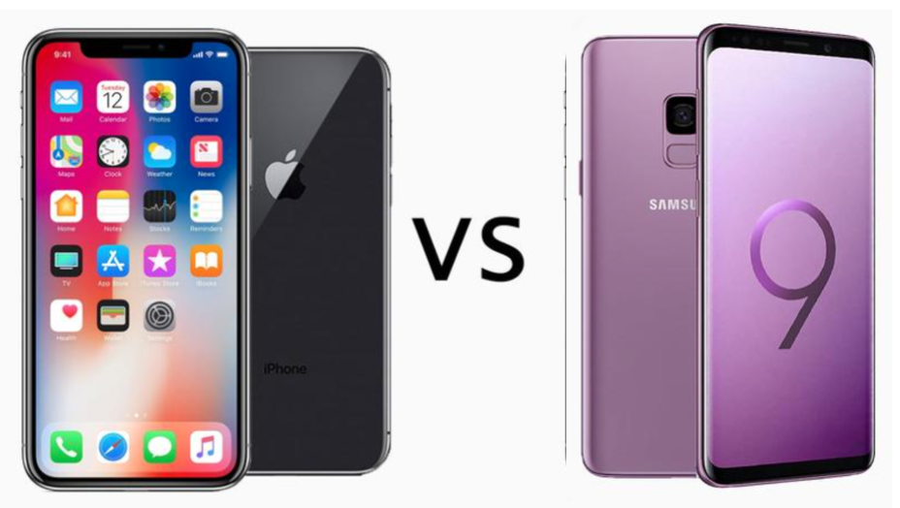

**Table of Contents**

1. Project overview
2. Sentiment findings for iPhone versus Galaxy
3. Confidence in modeling results
4. Impact of findings
5. Methodology used

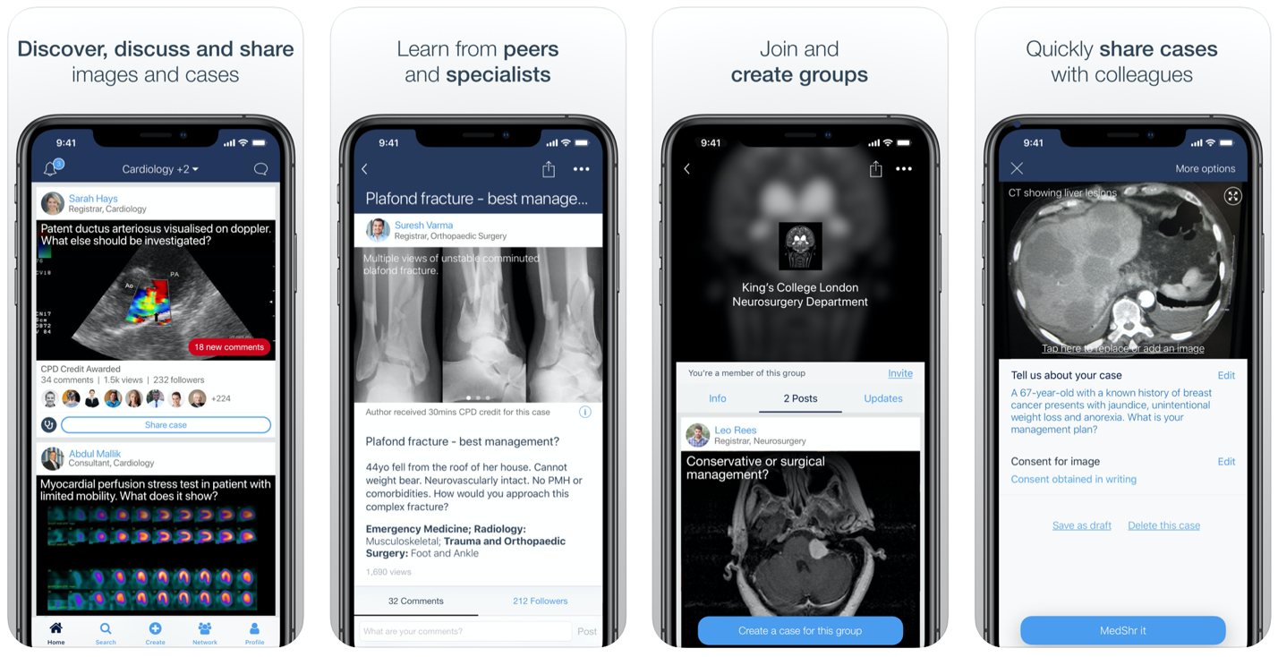

1. **Project Overview**
   1. Who is the client and what do they do?
      1. Client: Helio Health
      2. Business: Smartphone & tablet app developer
   2. What is the project?
      1. Teamed with a government health agency to develop a suite of smartphone medical apps to be used by aid workers in developing countries
      2. Apps will do the following:
         1. Enable aid workers to communicate with medical professionals located elsewhere in order to manage local health conditions
         2. Allow medical professionals to diagnose conditions through the examination of images and other data uploaded through the app
      3. Government agency requires the apps to be bundled with a smartphone’s software
   3. Project goal
      1. Provide the client with a report that contains the following:
         1. Analysis of sentiment toward the iPhone and Galaxy
         2. Description of the methods and processes used to develop our conclusions
   4. What we have been asked to do
      1. Examine the positive and negative attitudes on the Web towards both the iPhone and Galaxy
      2. Predict the sentiment for both the iPhone and Galaxy using machine learning models trained to understand patterns of sentiment present in smaller data sets
2. **Sentiment Findings**
   1. Sentiment distribution for small matrices used to train the models
      1. The histograms below show little variance in the sentiment distribution of the two smartphones.





* 1. Number of observations in data set used to make prediction: 20,570
  2. Categories
     1. 1: Unclear
     2. 2: Negative
     3. 3: Neutral
     4. 4: Positive
  3. iPhone Sentiment Rating Predictions

|  |  |  |  |  |
| --- | --- | --- | --- | --- |
|  | **Sentiment Category** | | | |
| **Smartphone** | **1** | **2** | **3** | **4** |
| iPhone | 9,693 | 1,000 | 1,152 | 8,725 |

* 1. Galaxy Sentiment Rating Predictions

|  |  |  |  |  |
| --- | --- | --- | --- | --- |
|  | **Sentiment Category** | | | |
| **Smartphone** | **1** | **2** | **3** | **4** |
| Galaxy | 9,795 | 1,121 | 1,302 | 8,352 |

* 1. Comparisons of the Predictions
     1. By phone

View 1

View 2

* + 1. By sentiment category
  1. Conclusions
     1. Even though the iPhone fared slightly better than the Galaxy, there is not a very strong preference for it over the Galaxy. The iPhone only scored 373 points higher than the Galaxy in the “positive” category.
     2. The histograms of the small data sets used to train the models along with the three charts relating to the sentiment predictions prove that the distributions of both phones are essentially the same. There is not enough variance between them to make a definitive choice of one smartphone over the other.

1. **Confidence**
   1. iPhone model
      1. Algorithm: Gradient Boosting Machines
      2. Accuracy: 84.5%
      3. Kappa: 61.5%
         1. *measure of the precision of agreement between observations*
         2. *61% – 80% = substantial agreement.*
   2. Galaxy model
      1. Algorithm: C5.0 Decision Tree
      2. Accuracy: 84.2%
      3. Kappa: 59.3%
         1. *41% – 60% = moderate agreement*
2. **Implications**

Since there isn’t a strong preference for the iPhone over the Galaxy, it is very likely that there will be aid workers that use the Galaxy instead of the iPhone. Therefore, if the apps were only bundled with the iPhone software, then the aid workers that used a Galaxy phone would not have access to them and be able to provide the needed medical assistance. This would result in a failure to meet the Government Health Agency’s goal of all aid workers providing such assistance in developing countries.

To avoid this problem, we recommend that Helio negotiate a deal with both Apple and Samsung to have their apps bundled with each smartphone’s software.

1. **Methodology**
   1. **Step 1** – Assign Sentiment Rating to Observations in Two Small Matrices – One for the iPhone and one for the Galaxy
      1. An Alert Analytics team read the webpage that generated each observation in both matrices
      2. Based upon their review of the webpages, the team labeled each observation with one of the following sentiment ratings

0: Unclear

1: Negative

2: Somewhat Negative

3: Neutral

4: Somewhat Positive

5: Positive

* 1. **Step 2** – Explore the Data in Each Small Matrix
     1. Reviewed the data to understand what the attribute headers and their counts represent
  2. **Step 3** – Performed Feature Selection and Feature Engineering on Both of the Smartphone Matrices
     1. Purpose
        1. To develop several different data sets to find which attributes and algorithms will yield the highest possible performance and accuracy
        2. Four data sets created
     2. Definitions
        1. Feature Selection
           1. Process of selecting the attributes that contribute the most to the dependent variable
        2. Feature Engineering
           1. Process of selecting and transforming attributes in order to optimize the predictive capability of a model
  3. **Step 4** – Developed and Evaluated Several Models
     1. Algorithms considered
        1. C5.0 decision tree
        2. Random forest
        3. Support vector machine
        4. KKNN
        5. Gradient boosting machines
     2. Process
        1. Developed a model using each algorithm listed above for each data set created in the preceding step.
        2. Led to 5 models being created for each data set for a total of 20
        3. Evaluated the performance of each and selected one to make predictions
  4. **Step 5** – Applied Selected Model to the Large Data Set to Make Sentiment Predictions
  5. **Step 6** – Analyze Results and Report Findings